<!DOCTYPE html>

<html lang="en">

<head>

    <meta charset="UTF-8">

    <meta name="viewport" content="width=device-width, initial-scale=1.0">

    <meta http-equiv="X-UA-Compatible" content="ie=edge">

    <title>Document</title>

    <style>

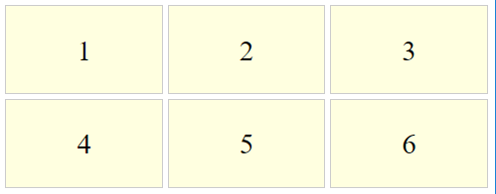    .child{

        padding: 1em;

        border: 1px solid #ccc;

        text-align: center;

        background-color: lightyellow;

    }

    .container{

        max-width: 1200px;

        margin: 0 auto;

        font-size: 2rem;

        /\* GRID \*/

        display: grid;

        grid-gap: 5px;

        /\* grid-template: grid-template-rows / grid-template-columns; \*/

        grid-template: repeat(2, 100px) / repeat(3, auto);

    }

    </style>

</head>

<body>

    <div class="container">

        <div class="child">1</div>

        <div class="child">2</div>

        <div class="child">3</div>

        <div class="child">4</div>

        <div class="child">5</div>

        <div class="child">6</div>

    </div>

</body>

</html>